IOStreams or File Handling
_______________________________________________________________________________
Q. What is Stream?
______________________________________________________________________
Stream means to transfer the data from one location to another location called as stream.
Means when we transfer data between one memory to another memory or one machine to another machine in network called as IOStream.
Example: if we think about file handling in file handling we transfer our program output or store our program output permanently in hard disk so if when we run program then output of program present in RAM and when store the output in file then file stored in hard disk means we send RAM to hard disk means we transfer the data between primary memory or RAM to secondary memory i.e to HARD DISK
called as IOStream.
If we want to work with IOStreams in JAVA we have java.io package in application.

Note: when we want to send data from one location to another location then we need to know the destination path.
If we want to work with path in JAVA we have File class from java.io package.

Now we want to discuss about the File class from java.io package
________________________________________________________________________________
File class is used for create the folder , create the file , get list of files and folder from specified path , get list of drive and its details like as total space of driver, free space of driver as well as provide method to identify retrieve path is file or folder as well as access current folder path etc

Constructor and Method of File
_______________________________ ___________________________________________
File(String path): this constructor can accept the file path using string format.
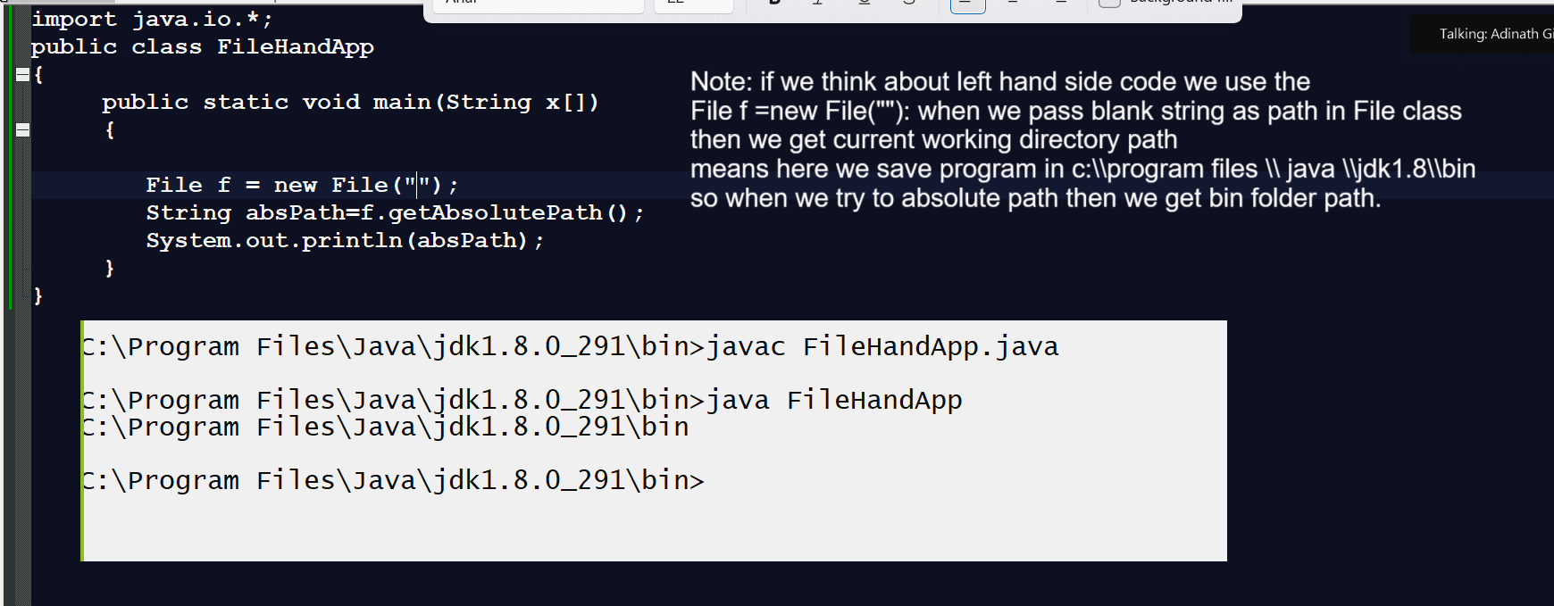

Note: Developer can provide the custom path according to his requirement then he need to specify exact path in string format shown in following example.
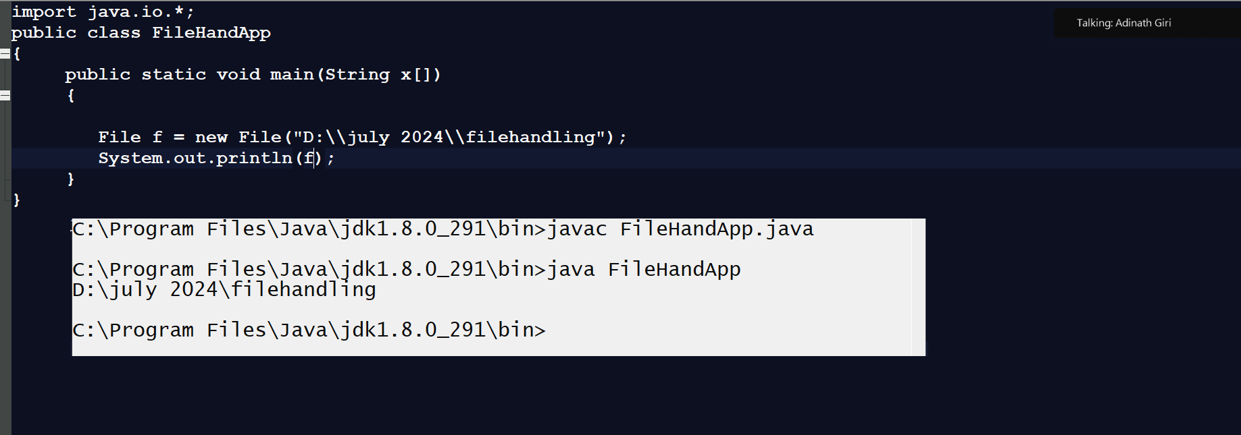

File(String parent, String child):
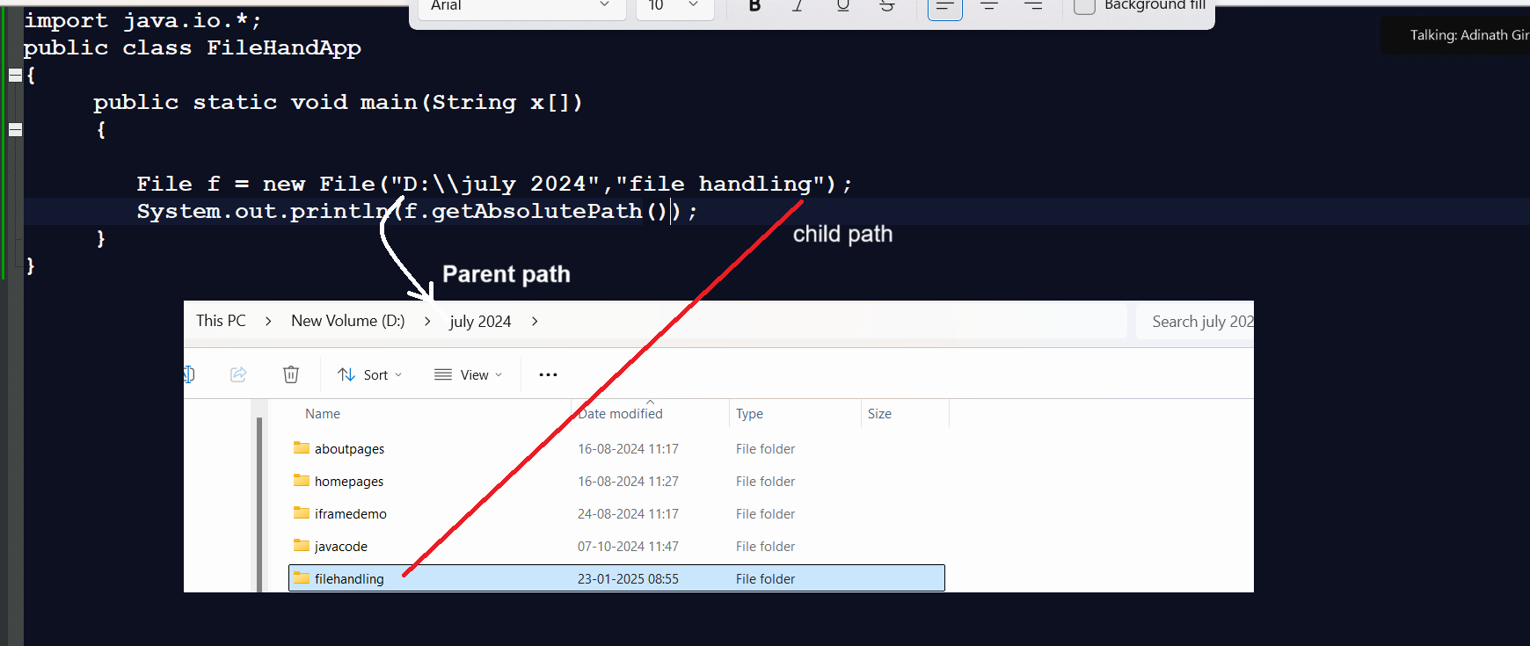
File(File parent, String child): this constructor help us to accept the path using file class reference as parent and child path using string format.
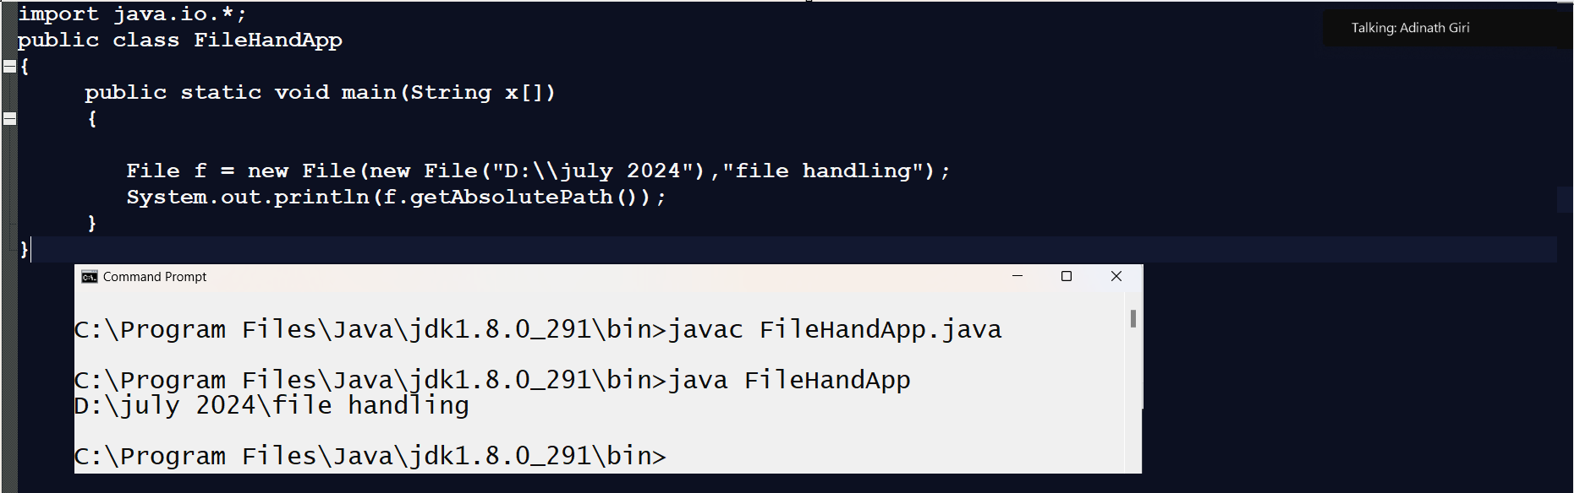

Methods of File class
___________________________________________________________________
static File [] listRoots(): this method help us to return list roots of system means return number of drive partitions.
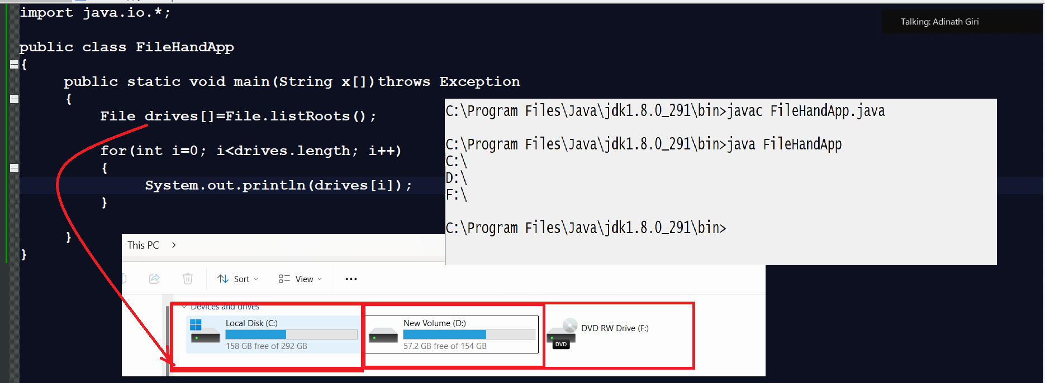

long getTotalSpace(): this method can return total space of particular drive in bit format.
long getFreeSpace() : this method can return free space of particular drive in bit format.
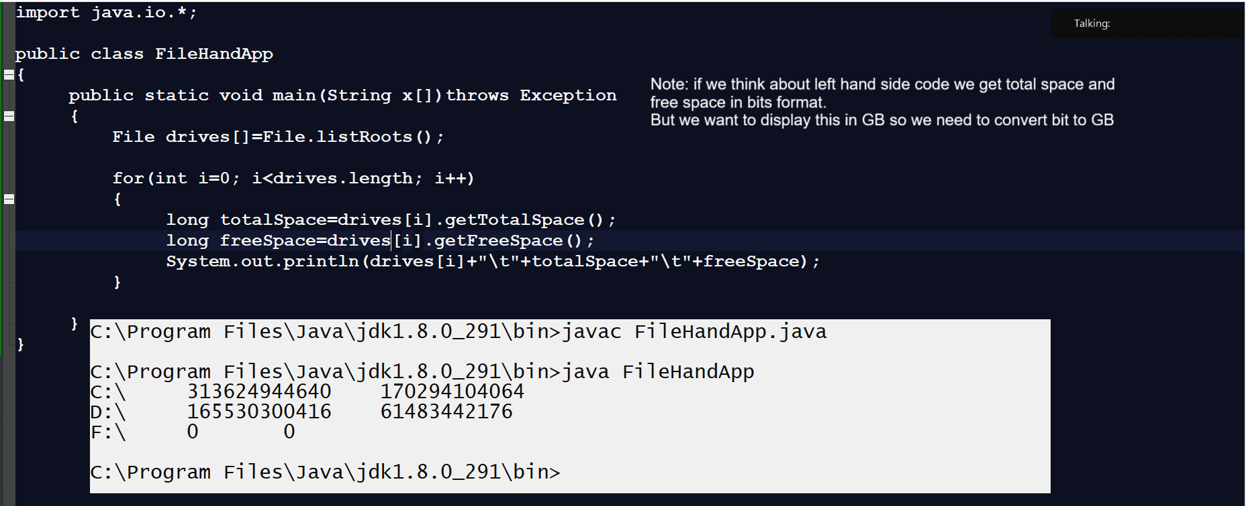
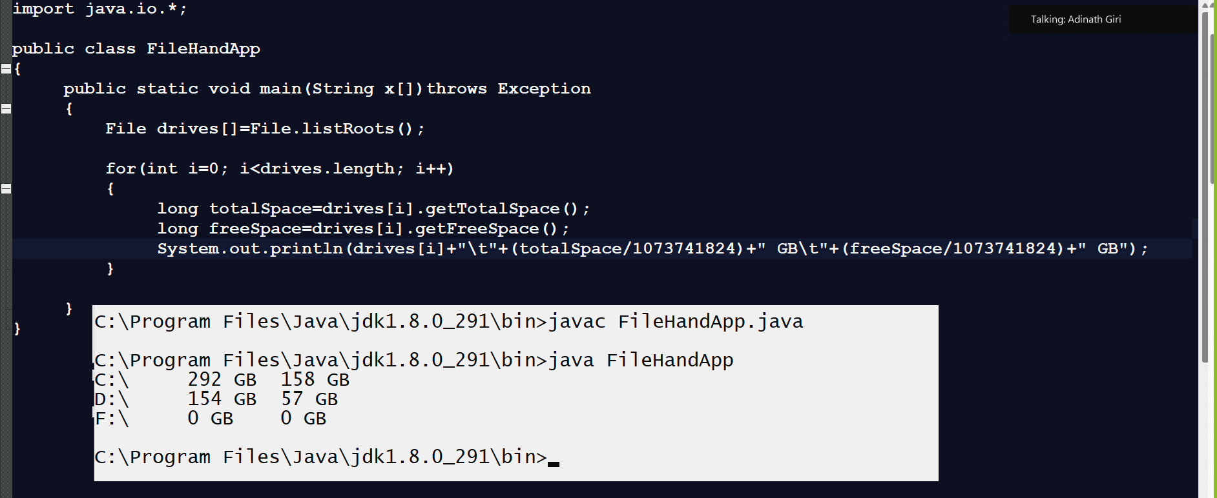
boolean mkdir(): this method helps us to create folder and return true if folder created successfully otherwise return false.
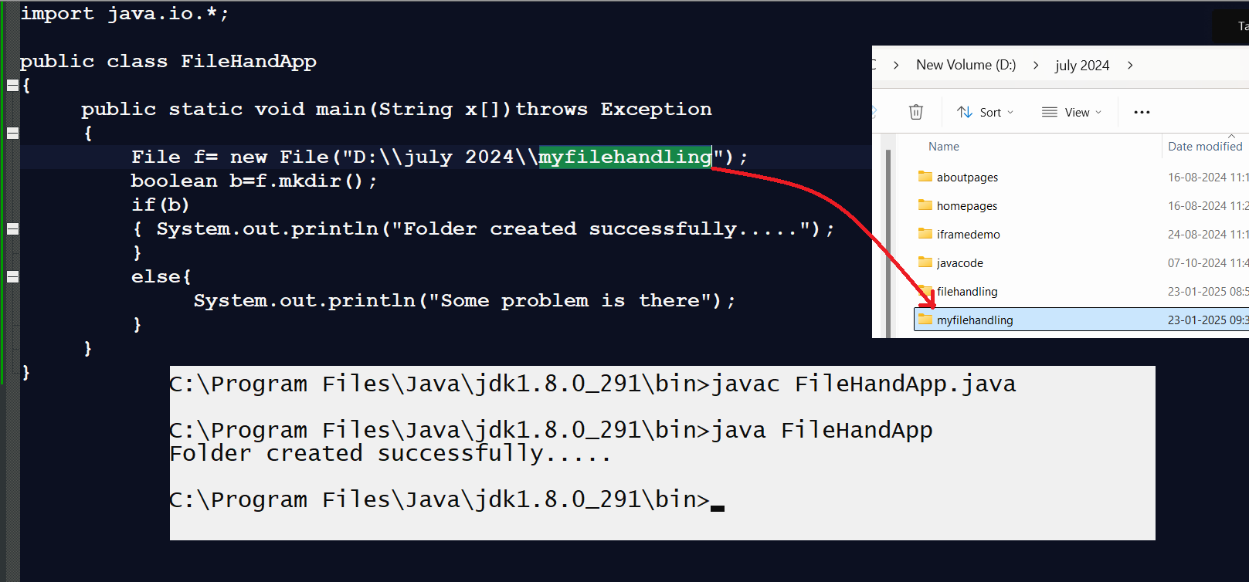
boolean exists(): using this method we can check file or folder is already present on specified path or not if present return true otherwise return false
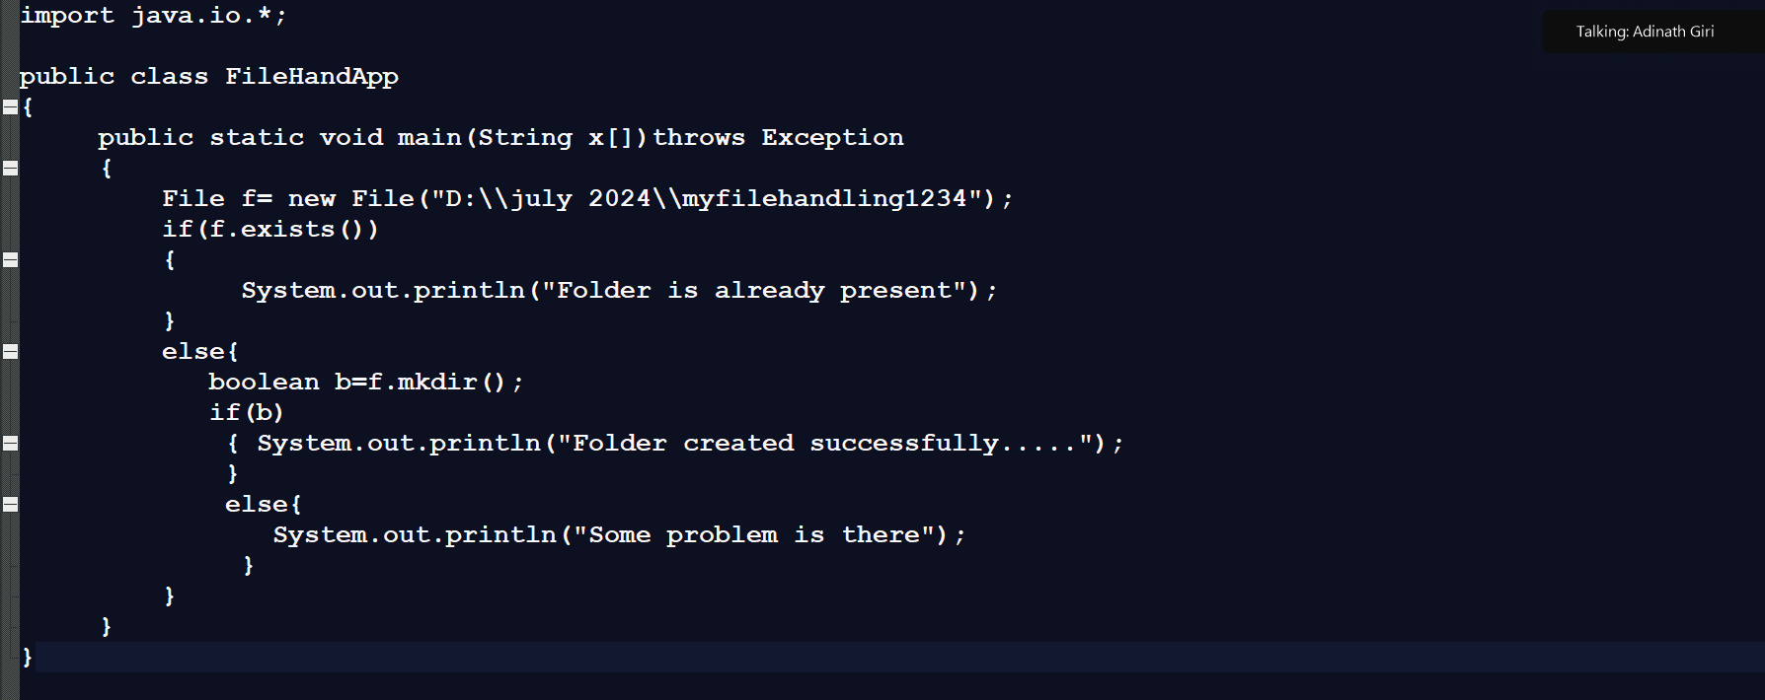

File [] listFiles(): this method helps us fetch all files and folder from specified drive
import java.io.*;
public class FileHandApp
{ public static void main(String x[])throws Exception
{
File f= new File("D:\\july 2024\\");
File list[]=f.listFiles();
for(int i=0; i<list.length;i++)
{
System.out.println(list[i]);
}
}
}

boolean isFile(): this method is used for check path is file or not if path is file return true otherwise return false.

Example: we want to only fetch files from destination path
import java.io.*;
public class FileHandApp
{ public static void main(String x[])throws Exception
{
File f= new File("D:\\july 2024\\");
File list[]=f.listFiles();
for(int i=0; i<list.length;i++)
{
if(list[i].isFile())
{
System.out.println(list[i]);
}
}
}
}
boolean isDirectory(): this method is used for check path is folder or not if path is folder return true otherwise return false.
import java.io.*;
public class FileHandApp
{
public static void main(String x[])throws Exception
{
File f= new File("D:\\july 2024\\");
File list[]=f.listFiles();
for(int i=0; i<list.length;i++)
{
if(list[i].isDirectory())
{
System.out.println(list[i]);
}
}
}
}
boolean createNewFile(): this method is used for create new file by using File class and if file is created return true otherwise return false.
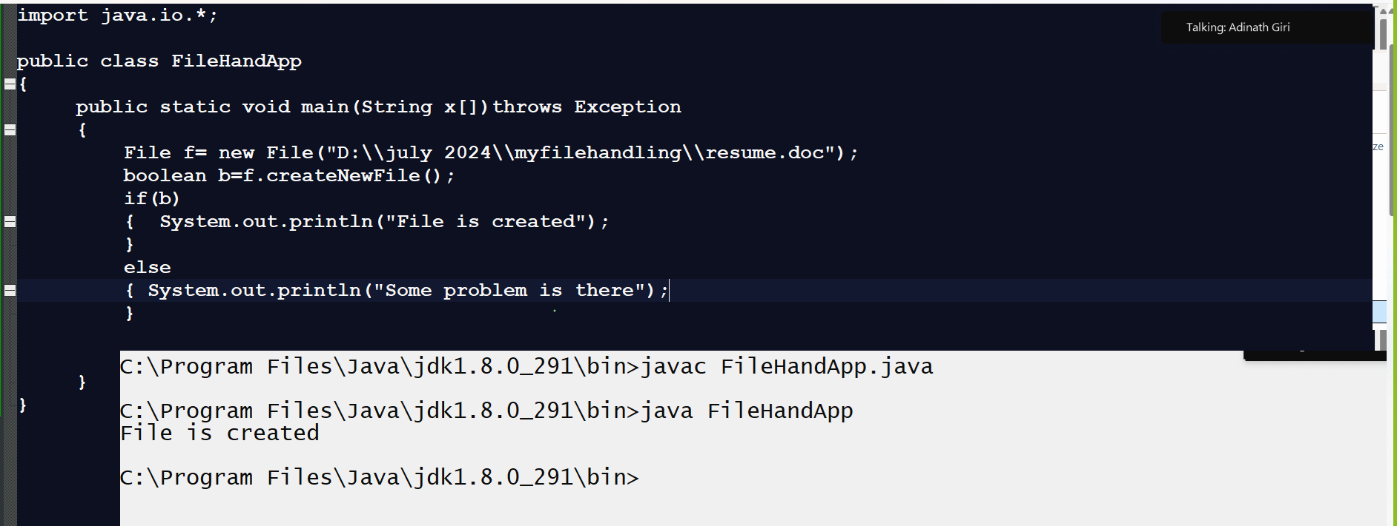

How to work with file using JAVA?
_____________________________________________________________________________
If we want to work with file in java means write data in file or read data from file then we have two ways.

a) Using Text format: when we want to work with text document like as notepad, WordPad etc. then we can use text format.
For work with text format java provide some two types of classes to us
1. Writer classes: when we want to write data in file using text format then writer classes help us
2. Reader classes: When we want to read file data using text format then reader classes help us.

b) Byte format: When we want to work with image, audio, video etc format then we can use byte format.
If we want to work with byte format then java provide Stream classes to us
1. Output Stream: Output Stream class helps us to write data in byte format
2. InputStream: InputStream class helps us to read data in byte format.

Now we want to discuss about Writer classes
_______________________________________________________________________________
Hierarchy of Writer classes
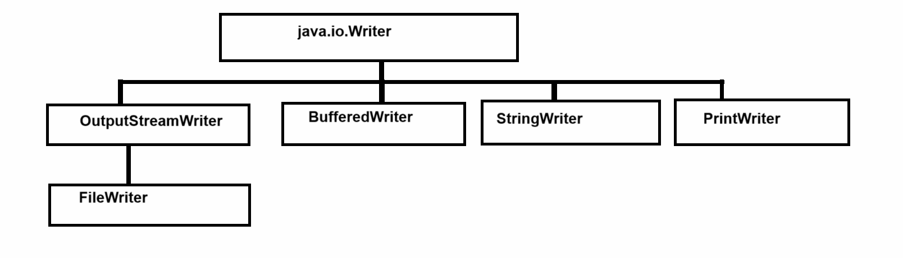
Now we want to discuss about Writer
____________________________________________________________________________
Writer class is parent of all text writing classes in JAVA and basically it is abstract class and it contain some abstract method which help us to write data in file using text format
Methods of Writer class
public void write(char) throws java.io.IOException: this method can write single character data in file at time.
public void write(char[]) throws java.io.IOException: this method can write character array data in file.
public abstract void write(char[], int, int) throws java.io.IOException: this method can write specified length of character array in file
Parameter Details
_________________________________________________________________________
char []: this parameter indicate we have actual data which we want to write file
int offset: indicate the index from that we want to write data in file
int length: decide how much data want to write in file.
public void write(java.lang.String) throws java.io.IOException: this method help us to send complete string in file
public void write(java.lang.String, int, int) throws java.io.IOException: this method help us to send some specified length of data in file
String : this parameter indicate we have actual data which we want to write file
int offset: indicate the index from that we want to write data in file
int length: decide how much data want to write in file.
void flush(): this method can flush the temporary of file pool
void close(): this function help us to close the file.

FileWriter class
__________________________________________________________________
FileWriter class helps us to write data in file using text format in single line.
Constructor of FileWriter class
________________________________________________________________________
a) FileWriter (String path): this constructor accepts the file path using a string format and this constructor used by default write mode.
Important point
When we write data in files we have two types of mode
a) Write mode: Write mode indicate if file not exist then create new file and write data in it and if file is exist then delete the previous data of file and write new data in file means override existing file data.
b) Append mode: Append mode means if file not exist then create new file and write data in it and if file is exist then persist or save previous data of file and add new data at the end of file

b) FileWriter (String path, boolean mode): this constructor accept two parameters in it
String path: this parameter indicate accept the file path using string format.
boolean mode: this parameter indicate file can use append mode or write mode means when we pass true then file can use append mode and when we pass false then file can use write mode.
C) FileWriter (File path): this constructor can accept file path using file class reference and use the write mode by default.
D) FileWriter(File path, boolean mode): this constructor can accept file path using file class reference and decide to write append mode or not if we pass true then we can write append mode if we pass false then use write mode.
Example: WAP to write single character in file using FileWriter class
_________________________________________________________________________
import java.io.*;
import java.util.*;
public class WriterApp
{ public static void main(String x[])throws Exception
{ FileWriter fw = new FileWriter("D:\\july 2024\\myfilehandling\\demochar.txt",true);
char ch;
Scanner xyz = new Scanner(System.in);
System.out.println("Enter single character data");
ch=xyz.nextLine().charAt(0);
fw.write(ch);
fw.close();
System.out.println("Data Save Success.....");
}
}

Example for writing character array in file
___________________________________________________________________
import java.io.*;
import java.util.*;
public class WriterApp
{ public static void main(String x[])throws Exception
{ FileWriter fw = new FileWriter("D:\\july 2024\\myfilehandling\\demochar.txt",true);
char ch[]=new char[5];
Scanner xyz = new Scanner(System.in);
System.out.println("Enter single character data");
for(int i=0; i<ch.length;i++)
{ ch[i]=xyz.nextLine().charAt(0);
}
fw.write(ch);
fw.close();
System.out.println("Data Save Success.....");

}
}

Example to pass string data in file
____________________________________________________________________________
import java.io.*;
import java.util.*;
public class WriterApp
{ public static void main(String x[])throws Exception
{ FileWriter fw = new FileWriter("D:\\july 2024\\myfilehandling\\demochar1.txt",true);
String data;
Scanner xyz = new Scanner(System.in);
System.out.println("enter data in file");
data=xyz.nextLine();
fw.write(data);
fw.close();
System.out.println("Data Save Success.....");

}
}
Example: Writing specified data in file from string
_______________________________________________________________________________
import java.io.*;
import java.util.*;
public class WriterApp
{ public static void main(String x[])throws Exception
{ FileWriter fw = new FileWriter("D:\\july 2024\\myfilehandling\\demochar2.txt",true);
String data;
Scanner xyz = new Scanner(System.in);
System.out.println("enter data in file");
data=xyz.nextLine();
fw.write(data,5,7);
fw.close();
System.out.println("Data Save Success.....");

}
}
Note: if we use the FileWriter then we can write data in file on same line and if we want to write data in file on new line we have one more class from java name as BufferedWriter class
Constructor of BufferedWriter class
_____________________________________________________________________________
BufferedWriter (Writer): this is the loose coupled constructor with Writer object means here we can pass reference of any child of writer class using up casting technique
BufferedWriter class provide newLine () method to us which help us to write data in file on new line

Example of BufferedWriter class
import java.io.*;
import java.util.*;
public class WriterApp
{ public static void main(String x[])throws Exception
{ Writer fw = new FileWriter("D:\\july 2024\\myfilehandling\\buffapp.txt",true);
BufferedWriter bw = new BufferedWriter(fw);
String data;
Scanner xyz = new Scanner(System.in);
System.out.println("enter data in file");
data=xyz.nextLine();
bw.write(data);
bw.newLine();
bw.close();
fw.close();
System.out.println("Data Save Success.....");

}
}
Reader classes
_______________________________________________________________________________
Reader classes help us to read data from file using text format and for that purpose we have some Reader class provided by java to us shown below.
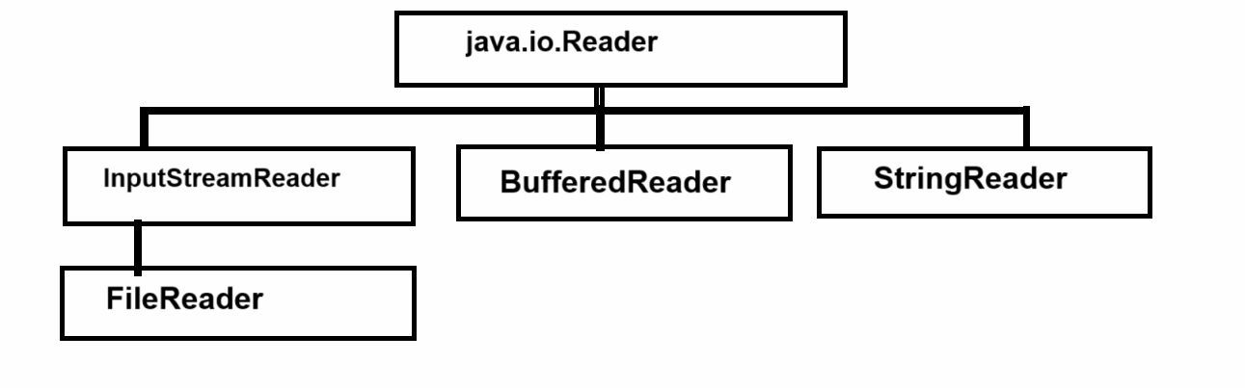
Note: if we think about above class hierarchy, we have Reader is top most class and it is abstract class it contains some abstract methods which help us to read data from file and for that purpose we have some methods provided by Reader class

int read(): this method can read single character at time from file and return its ascii code and when file end or file has no data return -1. when this method returns -1 then we consider file is end or file has no data.

int read(char[]): this method can read complete file and store its data in character array and return its length and when file has no data then return -1

int read(char[],int offset/index,int length): this method can read specific length of data from file.

void close(): this method can file the file

FileReader: This class can read data using character format
Constructor of FileReader
_______________________________________________________________
FileReader(String path): accept the file path using string format
FileReader(File path): accept the file path using file class reference.
Note: Reader class use by default read mode.
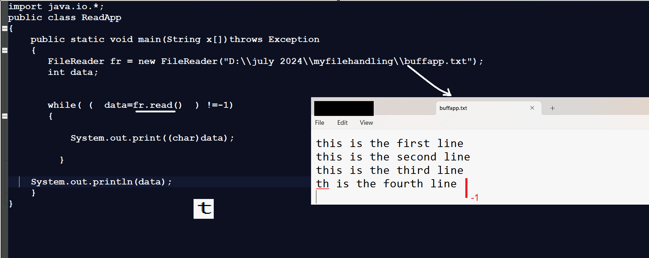
or

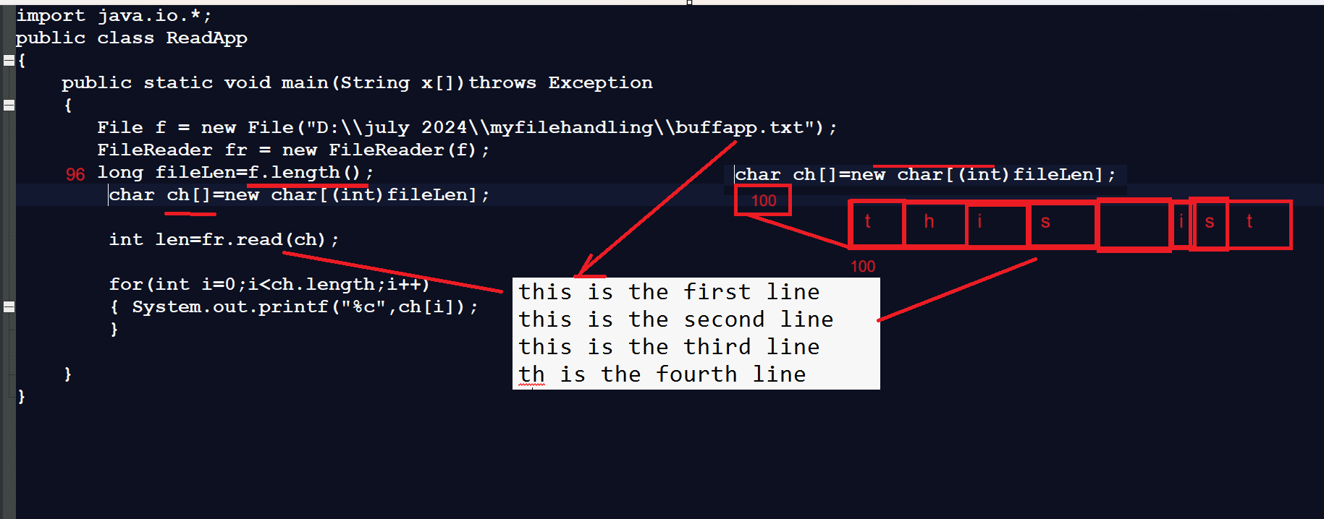
Note: if we use FileReader class we can read single single character from file but if we want to read file line by line then we can use BufferedReader class

Constructor of BufferedReader class
____________________________________________________________________________________
BufferedReader(Reader): if we think about BufferedReader constructor it contain reference of Reader means we can pass reference of any child of Reader in it or Reader reference by using Up casting technique.

String readLine(): this method can read complete line of data in text format and if data not found in file or file is end then return null

Example with source code
import java.io.*;
public class ReadApp
{
public static void main(String x[])throws Exception
{
File f = new File("D:\\july 2024\\myfilehandling\\buffapp.txt");
FileReader fr = new FileReader(f);
BufferedReader br = new BufferedReader(fr);
String line;

while( (line=br.readLine())!=null)
{
System.out.println(line);
Thread.sleep(4000);
}

}
}

How to read .csv file using BufferedReader class
_______________________________________________________________________________
Q. What is .csv file?
______________________________________________________________________________
CSV stands for comma separated file and basically file format where we can separate your data by comm. in file and it is text document people use it as alternate option of excel file
Q. What is use of .csv file?
__________________________________________________________________________
Normally developer use CSV file in application when they want to upload or store bulk data in database table or upload bulk data on server
Q. Why people use CSV if we have EXCEL File format?
____________________________________________________________________________
1. If we use Microsoft Excel then we need to installed Microsoft excel but if we use CSV we can open it using any text editor
2. Microsoft Excel file format only support on Microsoft windows operating system but CSV can support on any operating system.
3. CSV file format is very light weight format as compare Microsoft excel

How to create CSV file
_________________________________________________________________
1. Open text editor and save using .csv extension
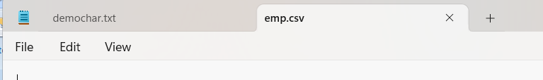

2. Store data in file by separating command
__________________________________________________________________________
Suppose example we want to store employee bulk data in file using CSV file and we have employee data like as id name and salary
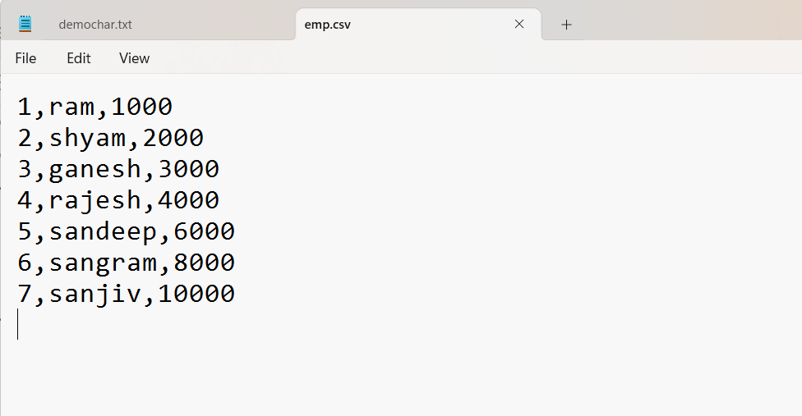
Note: we want to read CSV file using BufferedReader class and display its data.

import java.io.*;
public class ReadApp
{
public static void main(String x[])throws Exception
{
File f = new File("D:\\july 2024\\myfilehandling\\emp.csv");
FileReader fr = new FileReader(f);
BufferedReader br = new BufferedReader(fr);
String line;

while( (line=br.readLine())!=null)
{
String cols[]=line.split(",");

for(String col:cols)
{ System.out.print(col+"\t");
}
System.out.println();
}

}
}
Stream classes
____________________________________________________________________
If we want to work with byte format data, we can use stream classes if we want to work with stream classes, we have to use following class hierarchy
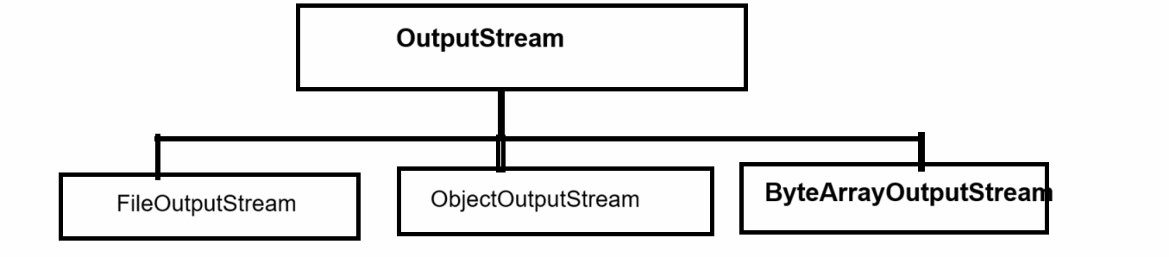
If we think about above hierarchy’s we have top most class name as OutputStream class and it contain some abstract methods which help us to write data in file using byte format.

Methods of OutputStream class
______________________________________________________________________________
void write(byte): this function is used for write single byte in file at time.
void write(byte[]): this function is used for write byte array data in file.
void write(byte[], int offset, int length): this method is used for write specified type of byte data in file.
void close(): this function help us to close the file.

FileOutputStream class
____________________________________________________________________
Constructor of FileOutputStream class
a) FileOutputStream(String path,boolean mode): this constructor helps us to accept the file using string format and decide file can use write mode or append mode.
b)FileOutputStream(String path): this constructor is used for accept the file path using string format and apply write mode on file
c) FileOutputStream(File path): this constructor is used for accept the file path using file class reference and apply write mode on it by default
d)FileOutputStream(File path,boolean mode): this constructor is used for accept the file path using file class reference and decide file can use append mode or not if we set true then file can use append mode if we set false then file can use write mode.

Example: we want to input string from keyboard and store in file using FileOutputStream class

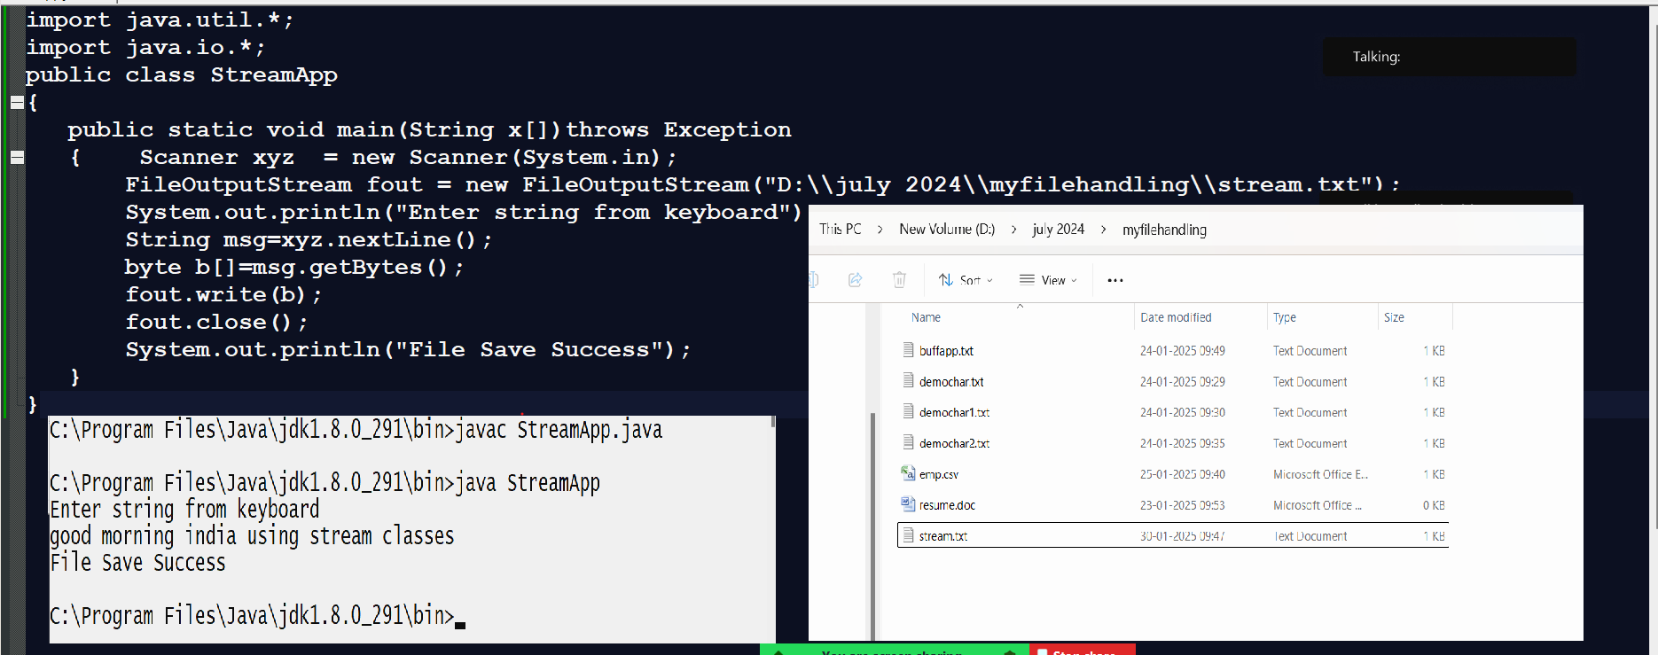

InputStream class
____________________________________________________________________________
InputStream class is used for read data by using byte format from file.
If we want to work with InputStream class we have some following class Hierarchy
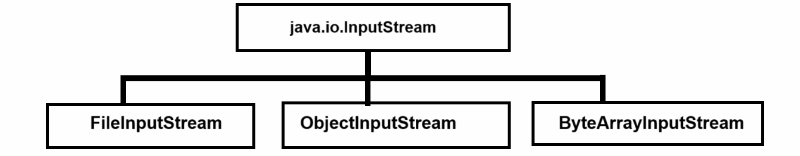

If we think about above diagram we have parent class name as InputStream and basically it is abstract class and it contain some abstract methods which help us to read data from file using byte format

int read(): this method is used for read single byte from file at time.
int read(byte[]): this method can read all data in byte format and return its length
int read(byte[],int offset,int length): this method can read data using byte format with some specified length.
void close(): close the file

FileInputStream:
_______________________________________________________________________
Constructor of FileInputStream class
_____________________________________________________________________
FileInputStream (String path): this constructor accepts the file path using string format.
FileInputStream(File path): This constructor accepts the file path using file class reference.
Note: All InputStream classes by use read mode.

Example: we want to read file using FileInputStream class
import java.io.*;
public class ReadFileApp
{
public static void main(String x[])throws Exception
{
FileInputStream fin = new FileInputStream("D:\\july 2024\\myfilehandling\\buffapp.txt");
int data;
while((data=fin.read())!=-1)
{
System.out.print((char)data);
Thread.sleep(500);
}
}
}

Now we want to see the difference between Reader and Stream classes

We want to see the example for identify the difference between Reader and Stream class
Example: we want to create code for image copy and paste
Means we want to read image from particular path and write on specified path for perform above task.

First Time we want to perform above code using Reader and Writer class

import java.io.*;
public class ReadFileApp
{
public static void main(String x[])throws Exception
{
FileReader fr = new FileReader("D:\\july 2024\\myfilehandling\\a.png");
FileWriter fw = new FileWriter("D:\\DS PPT\\a.png");
int data;
while((data=fr.read())!=-1)
{
fw.write(data);
}
fw.close();
fr.close();
System.out.println("Image copy paste successfully....");
}
}
Note: if we run above code and check the image at destination location where we write it then we found image get corrupted Because Reader and Writer classes not support to image or audio etc format i.e data which present in bits format so if we want to perform above tasks you can use Stream classes provided by Java To us

Second time we want to perform above code using Stream classes
import java.io.*;
public class ReadFileApp
{ public static void main(String x[])throws Exception
{ FileInputStream fr = new FileInputStream("D:\\july 2024\\myfilehandling\\a.png");
FileOutputStream fw = new FileOutputStream("D:\\DS PPT\\a.png");
int data003B
while((data=fr.read())!=-1)
{ fw.write(data);
}
fw.close();
fr.close();
System.out.println("Image copy paste successfully....");
}
}

Serialization and Deserialization
___________________________________________________________________________
Serialization: Serialization is process to write object data in file means if we want to store any class object in file then we can use serialization and when we perform serialization with file then JVM internally encrypt the object data and store in file.

Means when someone open the file see the file data then he/she get data in encrypted format means we can say using Serialization we can provide security to object by JVM so normally serialization perform with object when we want to store object data in file or send in network

Deserialization: Deserialization is process to read object data from file and decrypt it in originally called as Deserialization

How to perform Serialization process or how to implement Serialization
__________________________________________________________________________
If we want to implement the Serialization we have some important steps.

1. Create POJO class and implement the Serializable interface in it
Note: Serializable is marker interface in Java and we can say Marker interface means an interface has special run time environment provided by JVM and interface not contain any method called as marker interface

Example: Serializable, Cloneable etc.

Example with source code
import java.io.*;
class Employee implements Serializable
{
private int id;
private String name;
private int sal;

public void setId(int id)
{ this.id=id;
}
public int getId(){
return id;
}
public void setName(String name)
{ this.name=name;
}
public String getName(){
return name;
}
public void setSal(int sal)
{ this.sal=sal;
}
public int getSal(){
return sal;
}
}

2) Create Object of ObjectOutputStream class
____________________________________________________________________________
ObjectOutputStream class is member of java.io package which is used for write object data in file and serialize it.

Constructor of ObjectOutputStream class
________________________________________________________________________
ObjectOutputStream(OutputStream): this constructor can accept the reference of OutputStream class means we can accept reference of any child of OutputStream class in it.

Example with source code
public class SerializeApp
{
public static void main(String x[])
{
FileOutputStream fout = new FileOutputStream("D:\\DS PPT\\demo.txt");
ObjectOutputStream oout= new ObjectOutputStream(fout);
}
}

3) call writeObject() method of ObjectOutputStream class for write object data

Syntax: void writeObject(Object): this method can write any kind of data or any kind of object in file and encrypt it and store it.

Example with source code
import java.io.*;
class Employee implements Serializable
{
private int id;
private String name;
private int sal;

public void setId(int id)
{ this.id=id;
}
public int getId(){
return id;
}
public void setName(String name)
{ this.name=name;
}
public String getName(){
return name;
}
public void setSal(int sal)
{ this.sal=sal;
}
public int getSal(){
return sal;
}
}
public class SerializeApp
{
public static void main(String x[])throws Exception
{
FileOutputStream fout = new FileOutputStream("D:\\DS PPT\\demoemp.txt");
ObjectOutputStream oout= new ObjectOutputStream(fout);

Employee emp = new Employee();
emp.setId(1);
emp.setName("ABC");
emp.setSal(10000);

oout.writeObject(emp);
oout.close();
fout.close();
System.out.println("Employee data save in file");
}
}
Deserialization: Deserialization can perform by using ObjectInputStream class
Constructor:
ObjectInputStream ref = new ObjectInputStream(InputStream): we can pass reference of any child of InputStream class
Object readObject(): this method can read object data from file and decrypt it in original format.

Example with source code
import java.io.*;
class Employee implements Serializable
{
private int id;
private String name;
private int sal;

public void setId(int id)
{ this.id=id;
}
public int getId(){
return id;
}
public void setName(String name)
{ this.name=name;
}
public String getName(){
return name;
}
public void setSal(int sal)
{ this.sal=sal;
}
public int getSal(){
return sal;
}
}
public class DeSerializeApp
{
public static void main(String x[])throws Exception
{
FileInputStream fin = new FileInputStream("D:\\DS PPT\\demoemp.txt");
ObjectInputStream oin=new ObjectInputStream(fin);
Object obj=oin.readObject();
Employee e=(Employee)obj;
System.out.println(e.getId()+"\t"+e.getName()+"\t"+e.getSal());
}
}

Transient keyword
________________________________________________________________________
transient keyword is used for to mark field as non-serializable means when we use the transient keyword with any variable then variable data not stored in file using serialization

Example with source

import java.io.*;
class Employee implements Serializable
{
private int id;
private transient String name;
private int sal;

public void setId(int id)
{ this.id=id;
}
public int getId(){
return id;
}
public void setName(String name)
{ this.name=name;
}
public String getName(){
return name;
}
public void setSal(int sal)
{ this.sal=sal;
}
public int getSal(){
return sal;
}
}
public class SerializeApp
{
public static void main(String x[])throws Exception
{
FileOutputStream fout = new FileOutputStream("D:\\DS PPT\\demoemp.txt");
ObjectOutputStream oout= new ObjectOutputStream(fout);

Employee emp = new Employee();
emp.setId(1);
emp.setName("ABC");
emp.setSal(10000);

oout.writeObject(emp);
oout.close();
fout.close();
System.out.println("Employee data save in file");
}
}

